Anastashia Pelletier
MATH 494
Assignment 1

The Calculations Used:
To create the table, I had to find out the Innings Pitched (IP). This is needed information for the Earned Run Average (ERA) and Walks plus Hits per Inning Pitched (WHIP).

Formula for IP:
$$\frac{Outs Pitched (IPouts)}{3}$$
Since we are looking for the total career stats, we can use a summation to make this part easier.

Formula for Career IP:
$$Career IP=\frac{\sum{{IPouts}_{i}}}{3} , where i=row number$$

Now that we know an important bit of information, we can use it to figure out the career ERA, which we will use Earned Runs (ER) to solve for. Since ERA is an average, it is important to note that we cannot just add all of the values. Instead, we must use the summation of each stat in order to correctly calculate the career ERA. This will be the same for the other stats as well.

Formula for Career ERA:
$$Career ERA=\frac{\sum{{ER}_{i}}}{Career IP}, where i=row number$$

Let us start calculating the Batting Average of Opponent Against the Pitcher (BAA* or BAOpp). For this calculation, we need the number of Hits (H), Batters Faced by Pitcher (BFP), Base of Balls (BB), Hits by Pitches (HBP), Sacrificial Hits (SH), and Sacrificial Flies (SF).

Formula for Career BAOpp:
$$Career BAOpp=\frac{\sum{H_{i}}}{\sum{{(BFP-BB-HBP-SH-SF)}_{i}}}, where i=row number$$

For WHIP, we will use a few familiar stats. These stats are BB, HBP, H, and the career IP that we solved for previously.

Formula for Career WHIP:
$$Career WHIP=\frac{\sum{{(BB+HBP+H)}_{i}}}{Career IP}, where i=row number$$

The last statistic we will find is the Strikeout (SO) / Walk Ratio. This statistic is all known as (SO/BB). Just like the other we can use summation to calculate the career total for both players.

Formula for Career SO/BB:
$$Career SO/BB= \frac{\sum{{SO}_{i}}}{\sum{{BB}_{i}}}, where i=row number$$

Results:
Name | ERA | BAOpp | WHIP | SO/BB
Sandy Koufax | 2.76 | 0.202 | 1.11 | 2.93
Nolan Ryan | 3.19 | 0.203 | 1.28 | 2.04

* Batting Average Against (BAA) is another name for BAOpp. Source= What is BAA in Pitching?: Understanding the Key Stat for Pitchers - GCELT

Those that are not familiar with sabermetrics will think that Win Lose Rate is a good way to measure a pitcher’s skill. However, Win Lose Rate does not account for the individual achievements or failures of a pitcher. Instead to determine which year both Sandy Koufax and Nolan Ryan did their best in, we can compare the BAOpp, WHIP, and SO/BB to determine which year they both did their best.

When we look at BAOpp, we want something that is low. The lower the number, the less likely the opposing batter was able to get a fair hit from the pitcher.

Years with the Best BAOpp:
Name | Best Year( BAOpp ) | 2nd Best Year( BAOpp ) | 3rd Best Year( BAOpp )
Sandy Koufax | 1965(0.17) | 1963(0.18) | 1962(0.19)
Nolan Ryan | 1972(0.171) | 1991(0.172) | 1969(0.18)

For a pitcher’s WHIP statistic, any number that is around 1 the pitcher will be considered All-Star. However, any value that is less than or equal to 1 the pitcher will be considered elite.

Years with the Best WHIP:
Name | Best Year( WHIP ) | 2nd Best Year( WHIP ) | 3rd Best Year( WHIP )
Sandy Koufax | 1965(0.870) | 1963(0.884) | 1964(0.928)
Nolan Ryan | 1991(1.035) | 1990(1.069) | 1989(1.124)

Lastly, SO/BB is often considered a statistic that shows the pure skill of a pitcher. The Ideal pitcher has high SO and a low BB. Unlike the other variables used, the higher the value, then the better the pitcher.

Years with the Best SO/BB:
Name | Best Year( SO/BB ) | 2nd Best Year( SO/BB ) | 3rd Best Year( SO/BB )
Sandy Koufax | 1965(5.38) | 1963(5.28) | 1964(4.21)
Nolan Ryan | 1990(3.14*) | 1987(3.10) | 1989(3.07)
*… Pi

For Sandy Koufax, we can see a consistency in BAOpp, WHIP, and SO/BB. The best year was 1965. According to the parameters that was stated, all 3 variables show that Koufax was an elite pitcher in 1965.

For Nolan Ryan, while there was less consistency, there was one thing to note. BAOpp does use batting average of the opponent. This was a statistic that was talked about in the previous assignment. Based on what we learned, BAOpp has less weight than a pitcher’s WHIP and SO/BB. With that in mind, the best year would be 1990. In both WHIP and SO/BB, the pitcher performed amazingly well.

Scatterplots:

Analysis:
When looking at both scatterplots, it would be easily assumed that there is a negative correlation between ERA and Year. This is because of the R value of both graphs. However, the correlation is inconsistent and very weak, mostly due to the possibility of extreme outliers. For example, if we exclude the data from year 1966 for Nolan Ryan, then we still have a very low to no correlation.

In both of Nolan Ryan’s scatterplots, the R value is very minute. Even with the low value, the once negative correlation is now positive. Even the R² value is still so low that we would not be able to use this correlation as a predictive model.

Also, while Sandy Koufax data does seem like there is a weak negative correlation in which we can barely be able to use for predicting outcomes. This is only due to the small sample size. Koufax was a pitcher for 12 years verse Nolan Ryan, who pitched for 27 years. That is double the amount of data that we have. Ryan’s data is better at showing that there is such a small correlation between ERA and years, that we might as well say that the is no correlation.

Needed R Code for Both A and B:

library(readr)
TPD2000_2019 <- read_csv("MATH 494/Teams Pitching Data 2000 - 2019.csv")
View(TPD2000_2019)

library(tidyverse)
library(ggpubr)

R Code:

#Part A1: Calculating Win Percent
TPD2000_2019$WinPerc <- round(TPD2000_2019$W / TPD2000_2019$G , 3)

#Part A2: Calculating WHIP
IP <- TPD2000_2019$IPouts / 3
BBHBPH <- TPD2000_2019$BBA + TPD2000_2019$HA
TPD2000_2019$WHIP <- round(BBHBPH / IP, 3)

Scatterplots:
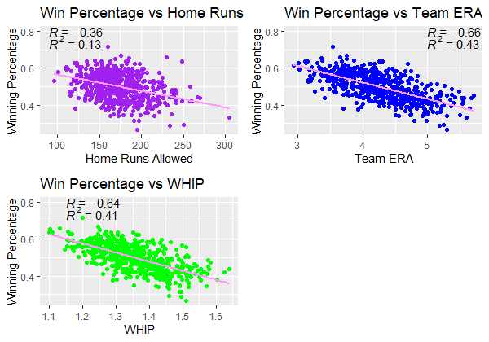
Analysis:
The one that have the strongest correlation with winning percentage is a team’s ERA. Even though it is a negative correlation, the R value is the furthest away from 0 and the closed value to |1|. Also, the R² is also close to .5, which means that a team’s ERA is slightly predictive in outcomes. Even visually, you can see that the data in ‘Win Percentage vs Team ERA’ is closer to the line of regression. This shows that out of the models, team ERA is the strongest.
I do not think that WHIP and ERA make good a good predictor for winning percentage. While both have slight correlations to winning percentage, their R² values show that they are week predictor. If their R² values were over .5. that would have been more ideal when it comes to prediction. However, both are less than .5, which means that they are either not predictive at all or only slightly predictive.
R Code:
#Part B1: Creating Scatter plots
wp_v_HRA<- ggplot(TPD2000_2019, aes(HRA, WinPerc)) +
geom_point(color="purple") +
geom_smooth(method = "lm", se=FALSE, color="#FF99FF") +
labs(title="Win Percentage vs Home Runs Allowed", x="Home Runs Allowed", y="Winning Percentage") +
stat_cor(aes(label=..r.label..),label.x=90, label.y=0.8) +
stat_cor(aes(label=..rr.label..), label.x=90, label.y=0.745)

wp_v_ERA<- ggplot(TPD2000_2019, aes(ERA, WinPerc)) +
geom_point(color="blue") +
geom_smooth(method = "lm", se=FALSE, color="#FF99FF") +
labs(title="Win Percentage vs Team ERA", x="Team ERA", y="Winning Percentage") +
stat_cor(aes(label=..r.label..),label.x=5, label.y=0.8) +
stat_cor(aes(label=..rr.label..), label.x=5, label.y=0.745)

wp_v_WHIP<- ggplot(TPD2000_2019, aes(WHIP, WinPerc)) +
geom_point(color="green") +
geom_smooth(method = "lm", se=FALSE, color="#FF99FF") +
labs(title="Win Percentage vs WHIP", x="WHIP", y="Winning Percentage") +
stat_cor(aes(label=..r.label..),label.x=1.15, label.y=0.8) +
stat_cor(aes(label=..rr.label..), label.x=1.15, label.y=0.745)

ggarrange(wp_v_HRA, wp_v_ERA, wp_v_WHIP, ncol=2, nrow=2)

Needed R Code for Both A and B:
library(readxl)
ODUBBFP23_24 <- read_excel("MATH 494/ODU Baseball Pitching File '23-24.xlsx",
sheet = "Data")
View(ODUBBFP23_24)

library(tidyverse)
library(gt)
library(RColorBrewer)
library(dplyr)

selectPitchers <- subset(ODUBBFP23_24,
Pitcher %in% c('Bashara','Finn','Pond','Sulpizio'))
strikePitchers <- select(selectPitchers, Pitcher,
PlateLocHeight, PlateLocSide))

strikeData <- data.frame(
Pitcher = c('Bashara','Finn','Pond','Sulpizio'),
Count_Pitcher = c(0,0,0,0),
StrikePer = c(0,0,0,0),
NumStrikes = c(0,0,0,0))

#Gather the number of Total Pitches
strikeData$Count_Pitcher <-table(strikePitchers$Pitcher)

#Gather the number of Total Stikes
strikePitcher <- filter(strikePitcher, !is.na(PlateLocSide))
strikePitcher$strikeCheck <- between(strikePitcher$PlateLocSide, -1, 1) &
between(strikePitcher$PlateLocHeight, 1.211,3.667)
strikePitcher |> group_by(Pitcher)|>
summarise(total = sum(strikeCheck)) -> totSt
totSt$total -> strikeData$NumStrikes

#Caluculate the Strike%
strikeData$StrikePer <- with(strikeData,
round((NumStrikes/Count_Pitcher)*100, 0))

Table:
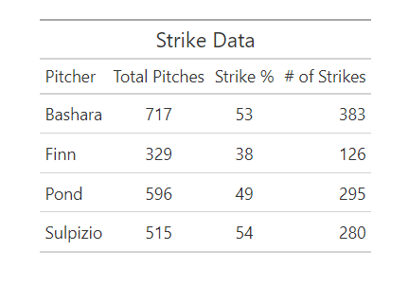

R Code:
gt(strikeData) |>
tab_header(title = "Strike Data")|>
cols_label(Count_Pitcher='Total Pitches',
StrikePer='Strike %',
NumStrikes='# of Strikes')

Bar Chart:
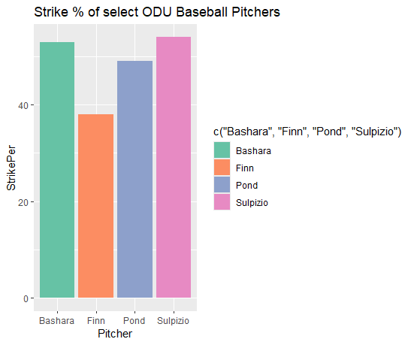
R Code:
ggplot(strikeData)+
geom_bar(aes(x = Pitcher, y = StrikePer,
fill = c('Bashara','Finn',
'Pond','Sulpizio')),
stat="identity")+
ggtitle("Strike % of select ODU Baseball Pitchers")+
scale_fill_brewer(palette = 'Set2')

